WHAT ARE HEALTHY HOLIDAY HINTS?

SIMPLE TIPS ON HOW TO MAKE THE BEST (AND AFFORDABLE) CHOICES

“THE BASIC REASONS FOR THIS BOOKLET REMAIN:

**People worry, “What the heck would be a good gift for _______??” Many are stumped trying to figure this one out. So, could an organization with “toxics” in its name help?

**Well, by offering a treasure trove of creative & healthy gift ideas that you can find on the web or locally in Rhode Island.

**In a world where most people have their homes crammed with “stuff”, the economy is tanking, budgets are shrinking & the environment is threatened, how to celebrate?

**Well, by learning about lots of healthy, inexpensive, environmentally friendly options for holiday gifting, activity, keeping loved ones well & happy.

**IT”S A WIN-WIN – SAVES MONEY, PLEASES PEOPLE, IMPROVES THEIR HEALTH AND PRESERVES THE PLANET.

WHAT’S DIFFERENT THIS YEAR?

1. A SLIMMER PRINTED “HEALTHY HOLIDAY HINTS” WITH UPDATED ADVICE, & WAYS TO FIND YOUR OWN GREAT IDEAS. ** Share this user-friendly booklet for busy people with neighbors, friends & family! ☺

2. THE EXPANDED TIP HEALTHY HOLIDAYS & LESS TOXIC LIVING WEB PAGE: **A place to find our previous Healthy Holidays Directories (along with this one) and additional helpful info & resources updated as needed, not just once a year. Check it out & pass along the link: HTTP://TOXICSINFO.ORG/LESSTOXIC.HTM

“HEALTHY HOLIDAY HINTS” HELPS YOU FIGURE IT OUT! USE, ENJOY! IF STILL PUZZLED, CONTACT THE ORGANIZATION THAT PRODUCED IT - TOXICS INFORMATION PROJECT (TIP). THEY WELCOME QUERIES ABOUT HEALTHIER LIVING.

2012 HEALTHY HOLIDAY HINTS
(SUMMING UP SIMPLE, SENSIBLE IDEAS FOR GREAT HOLIDAY LIVING & GIVING)
© 2012, Liberty Goodwin




IT’S TIME TO CELEBRATE – WITH FUN,
LAUGHTER, & HEALTHY, MEANINGFUL
SHARING WITH LOVED ONES

Once again, “Healthy Holiday Hints” is here to provide for you the basic ideas and info for calmer, simpler, healthier, more meaningful more affordable holiday gifting & celebration.

(Note: Tell your friends and family to see this and the older Healthy Holidays Handbooks on our website at: www.toxicsinfo.org/thoughts.htm) for more details and options.)

LAUGHINGLY, LOVINGLY LAVISHED UPON YOU BY:

TOXICS INFORMATION PROJECT (TIP)
LIBERTY GOODWIN, DIRECTOR
P.O. Box 40572, Providence, RI 02940
TEL. 401-351-9193, E-MAIL: TIP@toxicsinfo.org
WEBSITE: WWW.TOXICSINFO.ORG
(Lighting the Way to Less Toxic Living)

☺ ☺ NOTES ☺ ☺

EASY WAYS TO SUPPORT OUR WORK:

**BENEFIT TIP WHILE SHOPPING
OR SURFING THE WEB AT:
www.goodsearch.com/charityid=818190 OR

www.igive.com/welcome/lp1/index.cfm?c=38382&m=0

Name Us As Your Charity – We’ll Get A Small Donation

**VISIT THE TIP BOOKSTORE FOR IDEAS! at: www.toxicsinfo.org/tipstore.htm
Order with Igive or GoodShop.

**MOST OF ALL, MAKE A DONATION TO:
Toxics Information Project (TIP)
P.O. Box 40572, Providence, RI 02940

(TIP is an official 501C3 Non-Profit organization,
so all contributions are tax-deductible!)

☺ ☺ NOTES ☺ ☺

CONSIDER HAVING LIBERTY GOODWIN OR ANOTHER TIP SPEAKER LEAD A DISCUSSION FOR YOUR GROUP, SCHOOL OR LIBRARY. A variety of topics can be addressed – including food, cleaning, personal care – any of the concerns found in our booklets or website. Arrangements are flexible. CONTACT LIBERTY AT: 401-351-9193 OR BY E-MAIL: LIBERTY@TOXICSINFO>ORG

A LONG & LASTING GIFT: PROTECTING OUR FOOD SUPPLY & HEALTH: JOIN A RI WORKING GROUP VS. CONTAMINATION & TAKEOVER OF OUR FOOD SYSTEM


FACTORY FARMS + GMOS + PESTICIDES
= A DEADLY COMBINATION
A huge & dangerous threat to our food supply is lurking, one with the potential to contaminate & degrade our environment, soil, & agricultural capabilities, to destroy small farmers, and seriously damage our health & that of our kids. It is the triple threat of factory farming, toxic pesticides & genetically modified crops. Scientific evidence re: GMO toxicity is overwhelming, especially for our kids.
www.responsibletechnology.org/10-Reasons-to-Avoid-GMOs

GMOs are unhealthy. GMOs contaminate forever. GMOs increase herbicide use. Genetic engineering creates dangerous side effects. Government oversight is lax. The biotech industry uses "tobacco science" to claim product safety. Independent research & reporting is attacked & suppressed. GMOs do not increase yields, & won’t feed a hungry world. By avoiding GMOs, you contribute to the coming tipping point of consumer rejection, forcing them out of our food supply.

WHAT CAN WE DO ABOUT IT?

**Educate the public about the pervasiveness & the dangers.
**Counteract industry propaganda and misinformation.
**Support non-GMO & Organic farming & seed preservation. **Boycott companies fighting GMO labeling.
**Avoid buying products containing GMOs, & with other shoppers, let markets feel anti-GMO consumer pressure.
**Learn how to buy healthier food on a budget – & provide information on that to the public.

NEEDED: A FEW GOOD PEOPLE TO HELP ADDRESS THIS ISSUE ALONG WITH THE RI FOOD POLICY COUNCIL. CONTACT LIBERTY GOODWIN, DIRECTOR,
TOXICS INFORMATION PROJECT (TIP), LIBERTY@TOXICSINFO.ORG 401-351-9193

2012 HEALTHY HOLIDAY HINTS
A TIP Less Toxic Living Guide
© 2012, Liberty Goodwin



THREE IS A CROWD – BUT IT IS FUN WHEN

THEY ARE LAUGHING! ☺ ☺ ☺

TABLE OF CONTENTS

P. 2. KEEPING IT SIMPLE AGAIN: LOW-STRESS GUIDE TO HOLIDAY GIVING & LIVING!

P. 3. QUICK REVIEW – RULES OF GREAT GIVING

P. 4. SOME CONTRARIAN HOLIDAY IDEAS

P. 5. WEBSITES TO SIMPLIFY YOUR CHOICES

P. 6. PERSONAL CARE & CLOTHING

P. 7–8. LOCAL RESOURCES FOR GIVING & LIVING

P. 9. HEALTHY FOOD & DINING

P. 10–11 HEALTHY PETS & HOUSEHOLD CARE

P.12 A GIFT TO A WHOLE GENERATION, AND THE EARTH – PROTECTING OUR FOOD SUPPLY.

Booklet Prepared & Provided By:
TOXICS INFORMATION PROJECT (TIP)
LIBERTY GOODWIN, DIRECTOR
P.O. Box 40572, Providence, RI 02940
TEL. 401-351-9193, E-MAIL: TIP@toxicsinfo.org
WEBSITE: WWW.TOXICSINFO.ORG

KEEPING IT SIMPLE AGAIN – THE LOW-STRESS GUIDE TO HOLIDAY GIVING & LIVING
By Liberty Goodwin,
TIP Director

A FEW IMPORTANT PRINCIPLES ARE THE KEY
TO GIVING REAL, LONG-LASTING VALUE

We’ve covered most of the bases re: specific healthier gifts in our previous Healthy Holiday Handbooks & Hints. You can still find those detailed helpful suggestions by accessing the 2008, 2009, 2010 & 2011 HHH TIP holiday booklets online at: http://toxicsinfo.org/thoughts.htm .

So, what can we offer in print this year? A simple reminder and outline about the basic principles of healthier, more meaningful giving and celebration. Some of the long-time standby resources you can visit or consult. Some of the same assistance with info on how to please your loved ones even while on a recession-time budget. Again, we offer encouragement to imagine exciting, new, out-of-the-box, non-stereotype, often non-“stuff” gifts. Two more points:

**I want to emphasize anew the great joy we can offer by truly listening to & understanding our loved ones, their concerns as well as their passions. Not only can this involve donating to causes they espouse, it could be that just letting them know you “get it” could be the best gift of all.

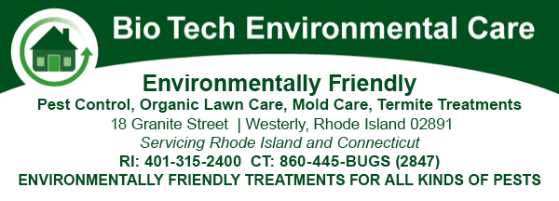
**The true spirit of giving doesn’t require getting credit for what we do. Consider any efforts you make towards a better, healthier world are a gift to those for whom you care.
Our new Food Protection project is one example – see P.

As before, if you still have questions about how to handle the holiday maze, we’d be pleased to help you with that, by E-Mail or phone: TIP@toxicsinfo.org or 401-351-9193.

TAKE US SHOPPING/SURFING WITH YOU. SEE BACK COVER FOR WAYS TO SUPPORT TIP AT NO EXTRA COST TO YOU.
HEALTHY HOLIDAY HOUSEHOLD CARE

IF IT IS NEW, IT STINKS! - Paint, carpets, etc., need time to “outgas” before entertaining! (Also, seek low-VOC options).

UNFORTUNATELY, IF IT SAYS “AIR FRESHENER”, IT LIES!
See our “Don’t Be Fooled About Fragrance” Booklet for facts on what’s in this stuff, dubbed an “air pollutant“ by the EPA:
http://toxicsinfo.org/TIPS_personal.htm

CLEANING UP FOR HOSTING: Vinegar & baking soda can do most cleaning. Try steam for floors, carpeting, upholstery.

COOKWARE & TABLEWARE: Use (and give) cast iron or steel pots pans (No Teflon), & glass or ceramic casseroles.
Don’t Microwave In Plastic!

For more good info on keeping a healthy, less toxic household, see: http://toxicsinfo.org/TIPS_house.htm

PREVENTING PESTS & SENDING THEM PACKING:

Keep food tightly covered or refrigerated. Even NYC cockroaches have been foiled this way. Also, traps & baits work without poisoning people as well as pests. Don’t spray! If you see a mouse, don’t go “Eek!”. Call David Jones at Bio Tech. They are truly “green” - helped TIP Director Liberty G with carpenter ants & termite problems – with no toxic residues. See ad below or go to: www.biotechpestcontrols.com (Note: They also have a new
number for Newport area folks: 401-619-5520)

PROTECTING PETS:


TWO GREAT RESOURCES – FOR HOLIDAY GIFTS
OR FOR YOUR OWN PRECIOUS PET!

AMERI-POOCH: Exciting natural pet products – including less toxic flea, tick and pet care options! Check them out!
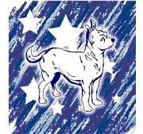
Ameri-Pooch L.L.C
Supporting American Jobs One Pet at a Time

All natural dog treats
baked on Site!

Promoting American made and environmentally friendly
pet products and companies.
74 North Main St.
401-371-2616
Pascoag, RI 02859 www.ameripooch.com

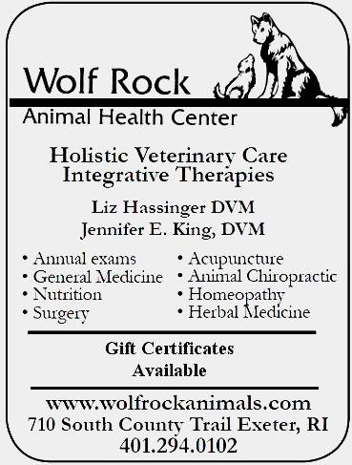

WOLF ROCK –
A TRULY HOLISTIC RHODE ISLAND VETERINARIAN!
Give your pet-loving friend or family member a gift certificate for truly natural health care!

MORE PET INFO: Pet hazards & healthy options, on the
TIP website at: http://toxicsinfo.org/protectpets.htm

A QUICK REVIEW – THE RULES OF GREAT GIVING

1. Thinking Outside the Box. Most important - don’t get caught up in the holiday ads & routine. Be creative & independent, not an obedient, easily led, “shopper”.

2. Listening, Loving & Participatory Giving/Shopping “Surprise!” is a gamble. Consulting the giftee can help you find a great gift fit!

3. Gift Certificates from Healthy Venues. These provide quality & choice! For shops, dining, museums, activities, travel. Encourage them to use these gifts – join them!

4. Active & Interactive Gifts for Children and/or Adults
Active toys such as model airplanes, bicycles, kites, balls. Doing things together, family games. Time & attention can bring people together and stimulate mind & body.

5. Charity Can Be a Buzz. Donations generate Xmas glow. Even better, doing things to help others – and bringing the kids along - can teach them the joy of giving unselfishly.

6. Lessons Can be Lovely: What would they like to learn? Playing music, art, other skills? Dance or “laughter yoga”? Another use for – Gift Certificates!

7. Introduce Them to Less Toxic Alternatives. Buying with advice from objective researchers can improve people’s lives & get them into healthier habits. See resources on P.5.

8. Group Gifting. Combining with others can make an expensive, but especially wonderful gift –– affordable.

9. Gifts of Services. By you or someone you pay to help. Repairs, cleaning, lessons, baby sitting – whatever service will be a boon to their busy lives.

10. Gifts of Appreciation. More than any “thing”, listening to, understanding and valuing people (especially kids) for who they are is the greatest gift of all

TELL THEM YOU SAW IT IN HEALTHY HOLIDAY HINTS

SOME CONTRARIAN IDEAS ABOUT HOLIDAYS

**For Some, the Whole Thing is a Big Burden!: Too much work, shopping, worry about the “right” gift. Free yourself – make deals with loved one to lessen the stress. Example: Agreeing to give gifts only to the kids – and just one each.

**Is It Selfish to Gift Yourself for the Holiday? Maybe, but the Good Book says “Love thy neighbor as thyself” – not “instead of”. Give yourself some time, relaxation, something healthy and rewarding.

**Rid Yourself of Toxics That Are Not “Chemical”!
Hate, anger, fear, grudges, impatience – isn’t there something called the “holiday spirit”? Get with it! ☺

Gifting Loved Ones At A Distance? Don’t! Wait till you can be together. Celebrating doesn’t need to be “on the day”!

**Are Advertisers Just Greedy Money-Grubbers? Not Ours!
We choose those featured in TIP booklets with care - as examples of honest sources for healthy, less toxic options. We’ve turned down those not up to our standards.

BREAKING THE “PREVIOUSLY OWNED” BARRIER
What Kind Of Gift Can Be Purchased “Used”?

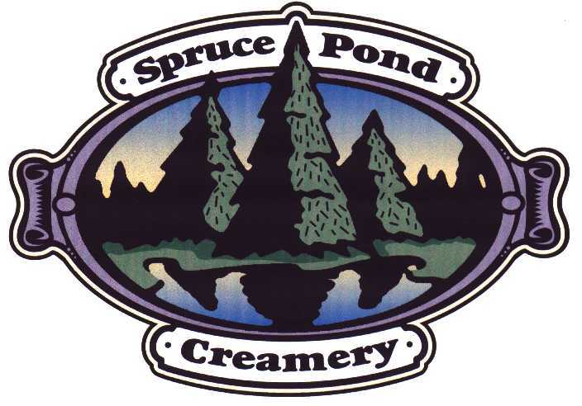
Any that are usable, work well, look good, & are sanitary. Wood, metal, glass, ceramic, small appliances, sports equipment. Avoid: clothing & stuffed furniture.

2ND TIME AROUND SPORTS,


328 Atwood Ave. Cranston, RI

Tel. 401-944-9380,

E-mail 2ndtime@cox.net.

Great Gifts for the Holidays.
Save 40-80 percent.
All used equipment sanitized with
an eco-friendly process using ozone and tea tree oil.

HEALTHY HOLIDAY FOOD AT HOME & AWAY

EWG’S SHOPPER’S GUIDE TO PESTICIDES IN PRODUCE:
What to buy organic? Find out at: www.ewg.org/foodnews

BUY FRESH OR FROZEN – NOT BPA-LACED CANNED FOOD

LOCAL OPTIONS FOR HEALTHY DINING

**LOCAL 121
121 Washington Street, Providence, RI Tel. (401) 274-2121
Lunch: Tuesday- Saturday, Dinner served nightly from 5pm.
A restaurant that strives to be ecologically, culturally, and
agriculturally sustainable. Working with small New England family farms and food artisans to provide seasonally inspired menus in the elegantly restored dining room of the historic Dreyfus Hotel in downtown Providence. www.local121.com

AS220
115 Empire St/95 Mathewson St / 131 Washington St, Providence, RI. This holiday season, give an AS220 Membership or Gift Certificate for classes & studio time in the Printshop (non-toxic solvents), Fab Lab, Photo Digital or B&W Darkroom. Support RI artists with unique gifts from AS220’s on-line store & not-for-profit galleries. Or, give a gift certificate for AS220 Foo(d),serving delicious, local, seasonal produce and, of course -- love! Learn more at: www.as220.org or call: 401-831-9327

**SPRUCE POND CREAMERY
370 King Street, Franklin, MA 02038.
(508) 520-7900 www.organicflatbread.com

Organic Thin-Crust Wood-Oven Pizza,
using a special mix of organic whole grain, unbleached and semolina flour.

Lasagna & Pasta Dishes, all organic Including meat, cheese,
& sauce. Sausage, pepperoni & cheese from Organic Valley.
All Natural Homemade Ice Cream, formerly at Maxmillian’s,
no hormones or antibiotics, & more! Worth a hop over the
state line - only 22 minutes from Providence, Exit 16 off Rte. 495.

GIVE THE GIFT OF ACTIVITY& NATURE

The East Bay Bike Path is beautiful all year, and if the weather doesn’t cooperate – consider bowling or dancing!

**YOUR BIKE SHOP
459 Willett Ave, Riverside, RI 02915,
Tel. 401-433-4491. Just off East Bay Bike Path.
AND 51 Cole St, Warren, RI 02885, Tel. 401-245-9755
Both shops have a large selection of road and mountain bikes, helmets, lights, bike bags, bicycle parts, and bike repair services. Call for hours – they change seasonally.

FLORAL & GARDENING GIFTS

If you know someone who loves to garden, there are scads of great gifts to encourage this healthy activity – & help them keep it free of toxic pesticide exposures. Books on organic methods are always a boon. Find some on our website at http://toxicsinfo.org/tipstore.htm For Less Toxic Landscaping info, go to: http://toxicsinfo.org/lesstoxic.htm

VISIT FREY, A TRULY"GREEN" PROVIDENCE FLORIST -THEY NEVER TREAT FLOWERS WITH CHEMICALS.

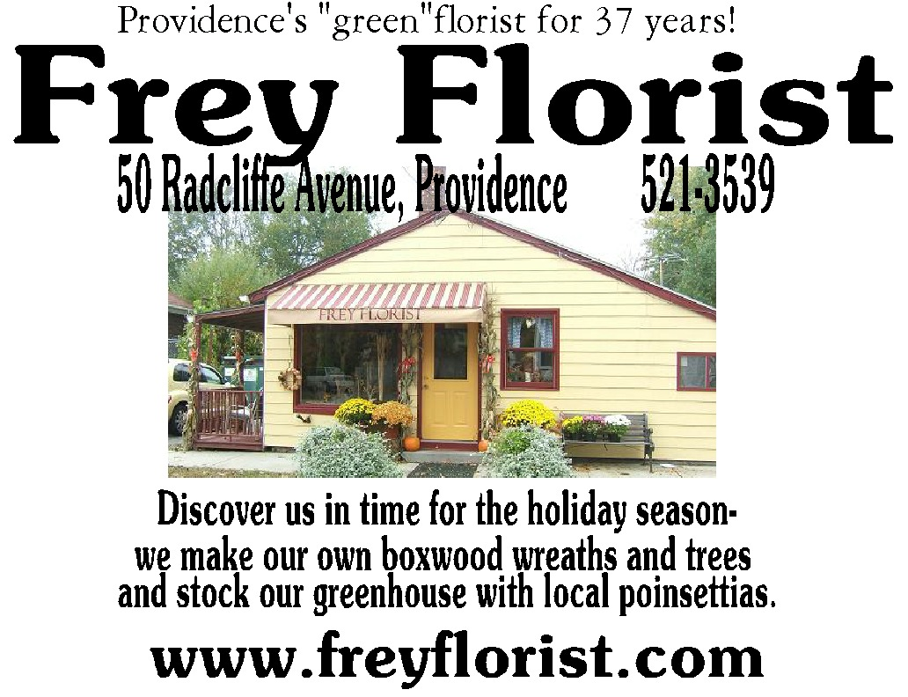

TELL THEM YOU SAW IT IN HEALTHY HOLIDAY HINTS

TIPS ON HOW TO IDENTIFY SAFER ALTERNATIVES AND AVOID THE “BAD GUYS” (Updated for 2012)

HOLIDAY KITCHEN TIPS,
Environmental Working Group (EWG)
www.ewg.org/healthyhometips/EWGsHolidayKitchen?utm_source=2012yeahhtngsubb&utm_medium=email&utm_content=first-link&utm_campaign=fund

HEALTHY CHILD HEALTHY WORLD.“Shop Healthy” guides.

http://healthychild.org/live-healthy/shop-healthy

ORGANIC CONSUMERS ASSOCIATION

(OCA) BUYING GUIDE:

Find Green Products and Services in Your Area

http://organicconsumers.org/btc/BuyingGuide.cfm

SIMPLE GIFTS – JOY ON A BUDGET!

HOLIDAY GIFTING:14 Ways To Give
More Meaning & Less Stuff

http://moneyandvalues.blogspot.com/2007/12/holiday-gifting-14-ways-to-give-more.html

“UNPLUG THE CHRISTMAS MACHINE”:
A ton of great ideas for low impact gifts & meaningful ways to celebrate the season. http://www.amazon.com/Unplug-Christmas-Machine-Complete-Putting/dp/0688109616

PRESENTS & MORE PRESENTS
(Combining With Others to Give) Yankee Swap, etc.
http://blog.washingtonpost.com/holiday911/2006/11/presents_and_more_presents.html


CHECK OUT RECYCLING SYMBOLS:

On the bottom of plastic items is a triangle with a number indicating type & toxicity of the plastic.

DON’T BUY PLASTIC WITH RECYCLING NUMBERS 3, 6 OR 7. DO BUY TOYS & CHILDREN’S PRODUCTS WITH THE SYMBOL, “CE” ON THE BOX OR ITEM.
These comply with tougher European Union standards
restricting phthalates & other chemicals.

PERSONAL CARE & CLOTHING

WARNING - WHEN BUYING NEW CLOTHING & LINENS: New garments & sheets come treated with chemicals for permanent press wrinkle resistance. To limit exposure to these chemicals, WASH NEW CLOTHES BEFORE WEARING. (100 per cent cotton flannel sheets are naturally wrinkle-resistant, so are less likely to have toxic residues in them).

CHECK INGREDIENTS OF ANY PERSONAL CARE PRODUCTS YOU BUY: Whether as a gift or for self, get the facts at the Environmental Working Group (EWG) “Safe Cosmetics” database: www.safecosmetics.org

KIDS USE COSMETICS TOO: There is even a special Parents’ Guide to Kids’ Personal Care Products at :www.cosmeticsdatabase.com/special/parentsguide

MOST “FRAGRANCE” IS A CHEMICAL PUZZLE:
Cut through the mystery to the real story in TIP’s informative booklet - described below, available online at: http://toxicsinfo.org/TIPS_personal.htm

DON’T BE FOOLED ABOUT FRAGRANCE!
Fragrance Fallacies & Fakery (Table of Contents)

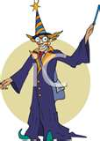
*FRAGRANCE ODDITIES & THE “FL” CHALLENGE
*MYSTERIOUS MATERIALS TOUR - *WHAT’S INSIDE?
*KNOWN BADDIES & SCENT SYMPTOMS
*REGULATION THAT DOESN’T & POLICIES TO PROTECT
*PLEASING PEOPLE? & SNIFF NOW, SORRY LATER.
*ACHIEVING APPEALING INDOOR AIR
*LINKS TO FRAGRANCE INFORMATION & RESOURCES
Be truly, naturally beautiful this holiday season! Check out the healthy, effective personal care options above, for yourself and your lucky giftees.

CHARITABLE & EDUCATIONAL GIFT-GIVING IDEAS

SOME RHODE ISLAND OPTIONS

**AMERICAN LUNG ASSOCIATION IN RHODE ISLAND
Fight for healthy air (see www.lungne.org or email
mclark@lungne.org) Give a gift of life--register someone for
Freedom From Smoking® premium on-line class & interactive
support ($15 for 3 months, $40/yr) at ffsonline.org. Radon test kit
(including analysis) $12.00. Registration fee for Stair Climb event
(in Providence or several other places in the Northeast) and/or
promise of pledge for Stair Climb event—For details, see:
www.Climbofyourlife.org.**

**SOUTH SIDE COMMUNITY LAND TRUST
109 Somerset Street, Providence, RI 02907, 401-273-9419
Give the gift of a yearly membership to SCLT, which helps people grow their own food in community gardens around Providence. Cost: $35 for individuals & $50 for families Includes:
10% discount at annual May plant sale & admission to special
pre-sale preview hour. See: www.southsideclt.org

**GUITAR AND MANDOLIN LESSONS

Classical, folk, and pop! It’s never too late to start!
Open new worlds to yourself! Learn to read and play music
in a short time! Paul Wilde, 401-751-4554 zenyente@gmail.com

FREE SUNDAY NIGHT JAMMERS DANCES!

One Sunday each month:
Potluck Supper: 6 p.m.
Dancing (with teaching): 7 to 9 p.m.

Waltz, Polka, Contradance,
Israeli, English, Scandinavian, Greek

… Goff Hall, 124 Bay State Road, Rehoboth, MA
See www.contradancelinks.com/jammers.html
For dates & details contact 401-751-4554;
or zenyente@gmail.com

